Standard Manuscript Template
Please Remove all Gray Text before Submitting. Replace the red text with words that apply to your work.
Study design
TITLE [Stay simple. Avoid long title]

Título [Português]

Authors:
Name LAST NAME¹, Name LAST NAME²
From ¹ Department [English], Institution [in native idiom], City (state or province), Country; ²Department [English], Institution [in native idiom], City (state or province), Country

ORCID:
Author full name: ORCID number [register on: https://orcid.org/register]
Author full name: ORCID number [register on: https://orcid.org/register]

Twitter and/or Instagram accounts [optional]
Author full name: account

Conflicts of Interest: Disclose
Financial source: Disclose

Correspondence: Author full name. Email: Email for correspondence

ABSTRACT [Up to 300 words in a single paragraph. It should not contain abbreviations, acronyms, or references]
Background: XXX. Aims: XXX. Results: XXX. Conclusions: XXX

HEADINGS: XXX [3 to 5 keywords must be listed, which are contained in the DeCS (http://decs.bvs.br/) or MESH (https://www.ncbi.nlm.nih.gov/mesh/)]

Visual abstract or central image [Choose an image that best represents your study or provide a visual abstract summarizing the main points of your study. See the example below]
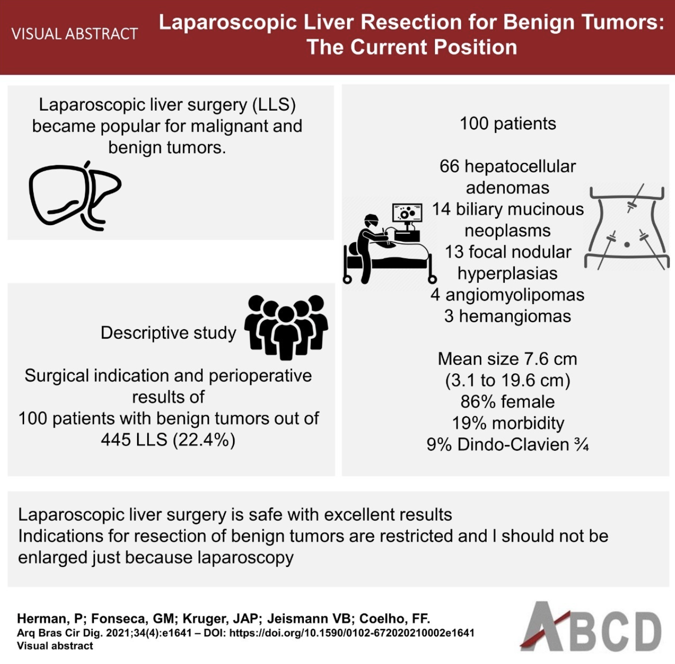
Caption: Caption

Central message
XXX [Write an overview of your study using simple words for social media purposes (maximum of 100 words)]

Perspectives
XXX [Explain the practical value of your study using simple words (maximum of 100 words)]

INTRODUCTION
XXX [This section should include: a clear statement of the purpose of this study; the rationale behind the development and/or use of this study with references to relevant studies]
METHODS
XXX [This section should include: study design; ethical approval; data source; eligibility criteria; extracted variables; outcomes; statistical analysis]
RESULTS
XXX [This section should include: baseline characteristics of the studied population; main findings]

Table 1. Caption [Tables should be presented in the body of the text next to where their results are written]

DISCUSSION
XXX [This section should include: a discussion of the main findings of the study; a discussion on the limitations of the study; discussion of future applications or directions of your research topic]
CONCLUSION
XXX [This section should include: a brief statement of what your work concludes, considering the study objectives]

ACKNOWLEDGMENTS
XXX [optional]

REFERENCES
XXX [List the references in alphabetical order of the authors' surnames and number them sequentially. If the referenced work has more than 6 authors, cite the first 6 authors and then use et al. When citing in the text, use the reference number in superscript form. At the end of each work, the doi number, if available, must be included.]

FIGURES
[A maximum of 6 images should be used. Images must be sent with a minimum resolution of 300 dpi.]
Figure 1. Caption

