
Standard Manuscript Template
Please Remove all Gray Text before Submitting. Replace the red text with words that apply to your work.
Study design
TITLE [Stay simple. Avoid long titles]
Título [Português]
Authors:
First name LAST NAME¹, First name LAST NAME²
From ¹Department [English], Institution [in native idiom], City (state or province), Country; ²Department [English], Institution [in native idiom], City (state or province), Country
ORCID:
Author full name: ORCID number [register on: https://orcid.org/register]
Author full name: ORCID number [register on: https://orcid.org/register]
Conflicts of Interest: [Authors must disclose any potential conflicts of interest, including financial, professional, or personal relationships that could influence the study. If there are no conflicts of interest, authors should state: “The authors have no conflicts of interest to declare.”]
Use of AI: [Authors must disclose any use of artificial intelligence tools in the preparation of the manuscript, including text editing, data analysis, image generation, figure preparation, translation, or language improvement. The name of the tool and its specific use should be described. If artificial intelligence was not used, authors should state: “Artificial intelligence tools were not used in the preparation of this manuscript.”]
Financial source: [Authors must inform all funding sources, grants, institutional support, or financial assistance related to the study. If the study received no funding, authors should state: “This study received no funding.”]
Ethical approval: [Authors must provide the name of the ethics committee or institutional review board that approved the study, as well as the approval number or protocol ID. When informed consent was waived, this should be clearly stated with the reason for the waiver. If ethical approval was not required, the authors must explain why, in accordance with institutional or national regulations. For studies involving humans, animals, or identifiable data, compliance with applicable ethical standards must be explicitly stated.]
Correspondence: Author’s full name and institutional address. Email: Email for correspondence

ABSTRACT [Up to 300 words in a single paragraph, structured in Background, Methods, Results, and Conclusion. It should not contain abbreviations, acronyms, or references]
HEADINGS: [3 to 5 keywords must be listed, which are contained in the DeCS (http://decs.bvs.br/) or MESH (https://www.ncbi.nlm.nih.gov/mesh/)]

Visual abstract or central image [Provide a visual abstract summarizing the main points of your study. See the example below]
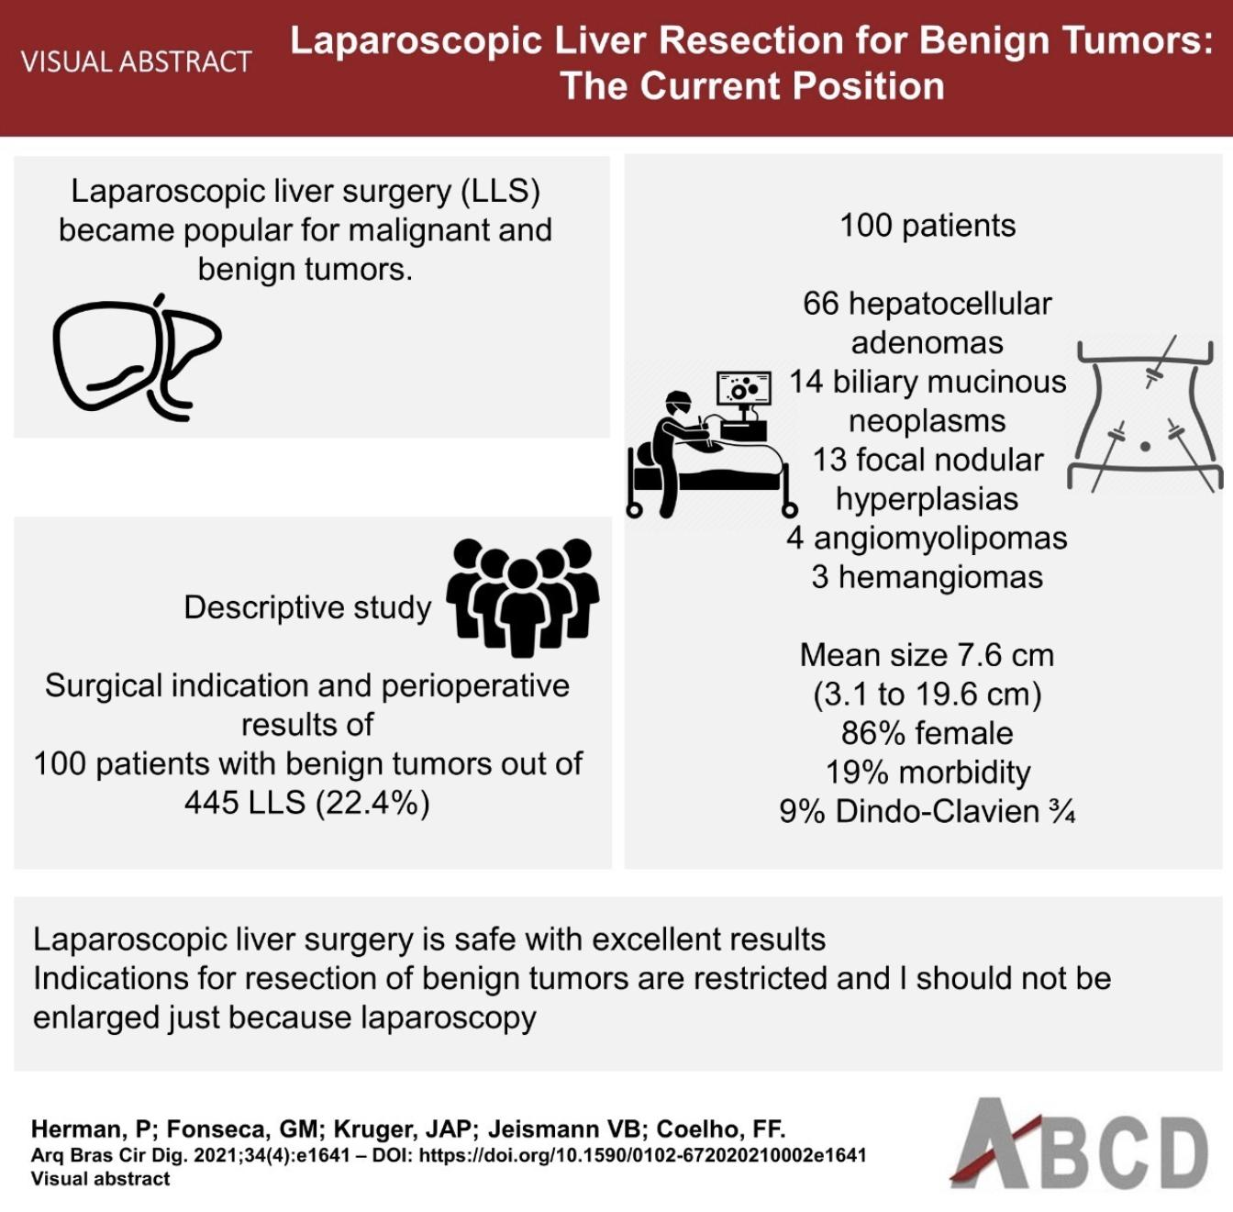

Central message
[Write an overview of your study using simple words for social media purposes (maximum of 100 words)]
Perspectives
[Authors must provide a brief statement, with a maximum of 100 words, explaining the future perspectives and potential implications of the study. This section should describe, in simple and accessible language, how the findings may influence clinical practice, research, education, health policy, or future investigations. Authors should highlight the practical value of the study, its possible impact beyond the immediate results, and how it may contribute to new hypotheses, improved decision-making, or further scientific development.]
Highlights
[Authors must provide 3 to 5 highlights in bullet-point format, summarizing the main findings, innovations, or methodological contributions of the manuscript. Highlights should be concise, objective, and written to improve online searchability and article discoverability, using relevant terms that readers are likely to search for. They should not repeat the title or abstract and must contain no more than 85 characters, including spaces. Each highlight should function as a brief “elevator pitch” of the article, allowing readers and search engines to quickly identify the study’s relevance and novelty.]

INTRODUCTION
[This section should include: a clear statement of the purpose of this study; the rationale behind the development and/or use of this study with references to relevant studies]
METHODS
[This section should include: study design; ethical approval; data source; eligibility criteria; extracted variables; outcomes; statistical analysis]
RESULTS
[This section should include: baseline characteristics of the studied population; main findings]
DISCUSSION
[This section should include: a discussion of the main findings of the study; a discussion on the limitations of the study; discussion of future applications or directions of your research topic]
CONCLUSION
[This section should include: a brief statement of what your work concludes, considering the study objectives]
ACKNOWLEDGMENTS
[optional]
REFERENCES
[List the references in alphabetical order of the authors' surnames and number them sequentially. If the referenced work has more than 6 authors, cite the first 6 authors and then use et al. When citing in the text, use the reference number in superscript form. At the end of each work, the doi number, if available, must be included.]

TABLES
Table 1. Caption [Tables should be presented in the body of the text next to where their results are written, at the end of the document, or in separate files.]

FIGURES
[A maximum of 6 images should be used. Images must be sent with a minimum resolution of 300 dpi.]
Figure 1. Caption

